HISTORY FILE :
WILL STORE ALL THE HISTORY INSIDE THE FILE
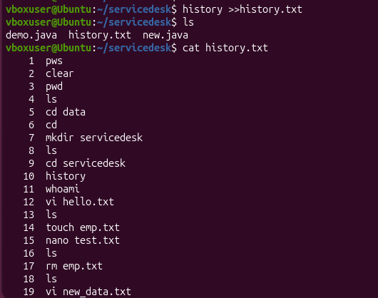
LS IN HOME :
SHOW ALL THE FOLDER STURCTURE

DATA.LOF FILE IS NOT IN THE DATA DIRECTORY:
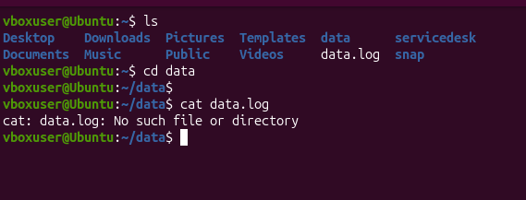
~/DATA WILL CONSIDER THE HOME DIRECTORY PATH:
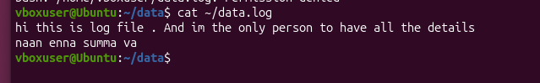

MKDIR-P :
WILL CREATE THE NEW DIR INSIDE THE DIR
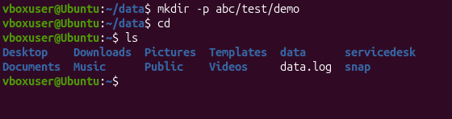
CD:
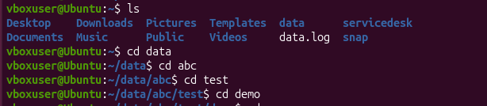
CD ../../..:


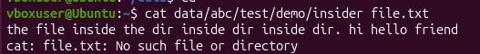

LS -LSTR :
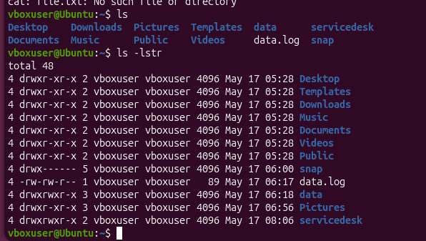
LS-A :
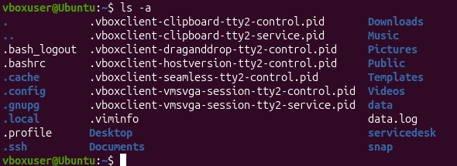
WILL SHOW ALL THE HIDDEN FILE IIN THE FOLDER

